3 Categories of Messianic Prophecy
Steven Rudd, May 2025
All messianic prophecies fall into three categories
Category 1: Texts that were universally recognized as predicting a single, clearly defined future messianic event at the time they were written. These texts can be used a proof that the Bible is inspired.
- Daniel 2:31-45 is an “event prophecy” of five kingdoms that predicts that the church will be established as the 5th kingdom during the days of the 4th kingdom of Rome.
- Daniel 9:24-27 is a “time prophecy” of the arrival of the Messiah that predicts 490 years from Ezra 7 (458 BC) to the resurrection of Christ on the 5 April AD 33. The time prophecy is exactly 490 solar years to the day.
- Balaam’s rising “star” messianic prophecy was reflected on the first century “widow’s mite” coin (Mark 12:41–44) as an 8-pointed star (Num 24:17).

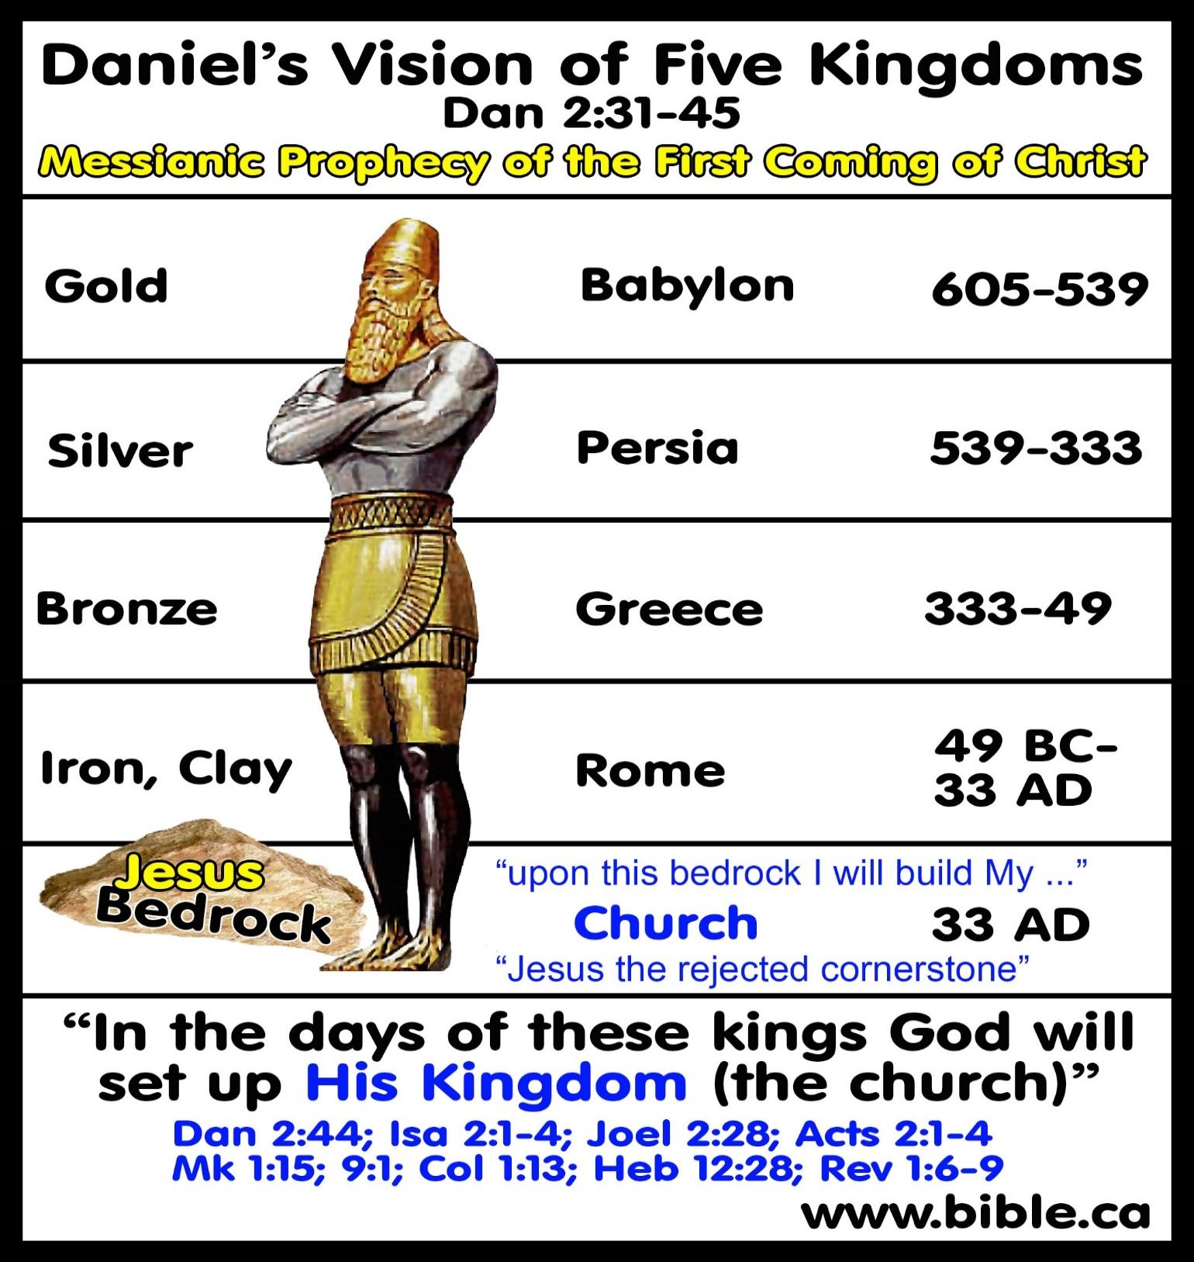
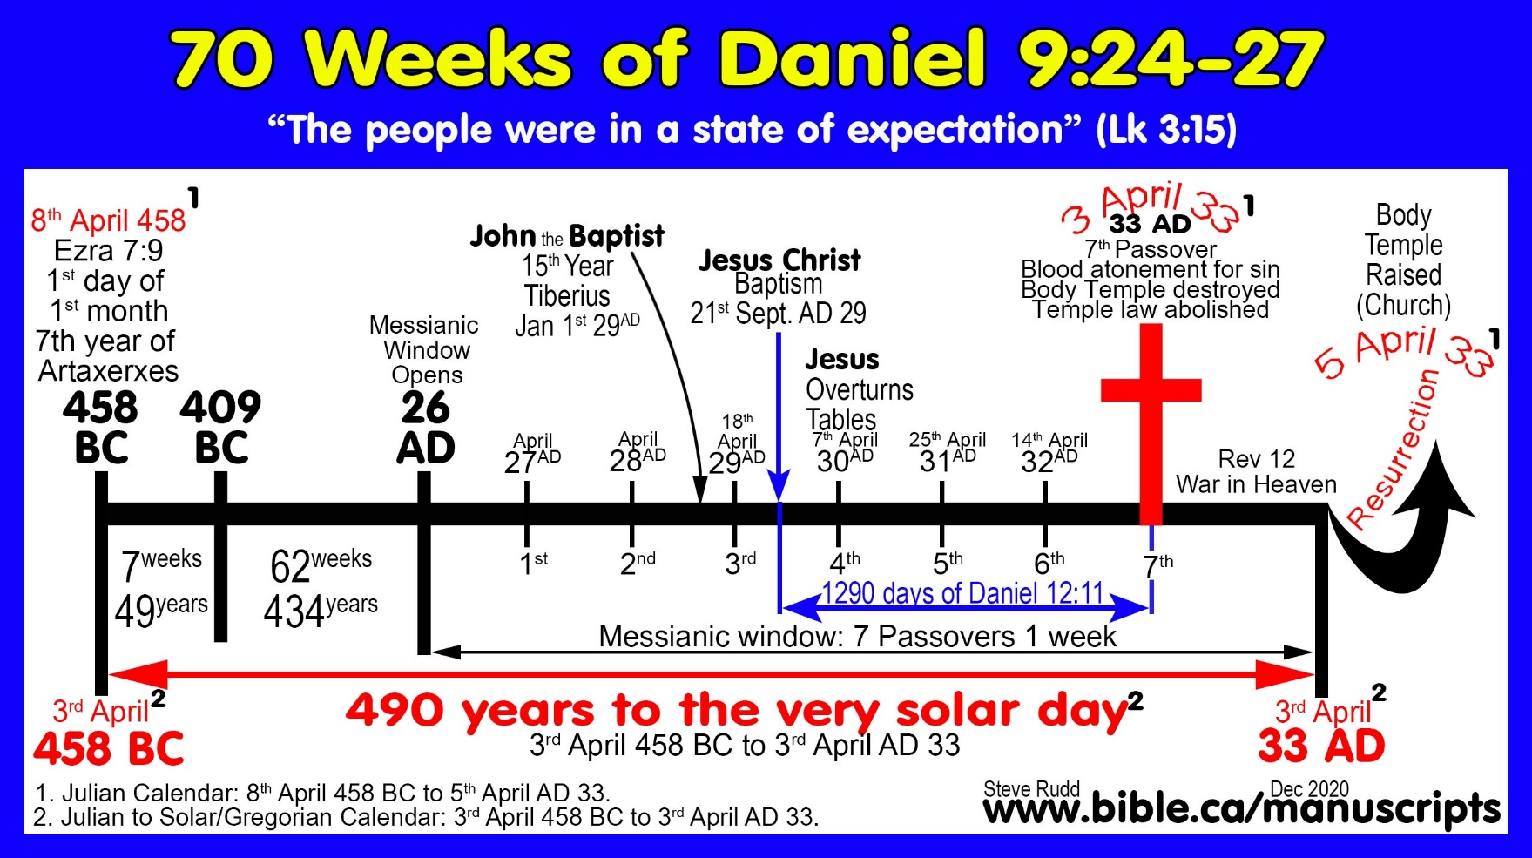

Correct interpretation of Daniel 9:24 and the 70 Weeks:
- The 70 weeks = 7 x 70= 490 years
- It starts with the decree to rebuild Jerusalem in April 458 BC (Ezra 7:7-26)
- The last week is the resurrection of Christ in April 33 AD.
  - A correct translation of the Hebrew word in the Masoretic Text for “Middle” (middle of week) is correctly translated “Half” correctly rendering the phrase, “the messiah will be cut off in the [last] half of the week.
  - It was during the last half of the 70th week that started with Jesus being baptized and ended with his crucifixion and finally resurrection.
  - The messiah was cut off at the end of last half of the 70th week.
- Jesus the Messiah rose from the dead 490 solar years to the very day Artaxerxes issued his decree:
  - The decree to rebuild Jerusalem in Ezra 7:7-26 records Ezra departing Babylon for Jerusalem on 1st Nisan (first month in Jewish Calendar) in the 7th year of Artaxerxes in 458 BC which translates to 8 April 458 BC (Julian calendar) and to 3th April 458 BC (Solar/Gregorian Calendar).
  - The resurrection of Jesus was on 16th Nisan 33 AD (Jewish Calendar) which translates to 5 April 33 AD (Julian calendar) and to 3rd April AD (Solar/Gregorian Calendar).
  - The solar calendar (Gregorian Calendar) is God’s Calendar for a year because it is the exact time it takes the earth to orbit the Sun.
  - Today we use the Gregorian Calendar which requires leap years to keep it is in sync with God’s solar calendar. The 490 years of Daniel’s 70 weeks is exactly 490 solar years to the very day.

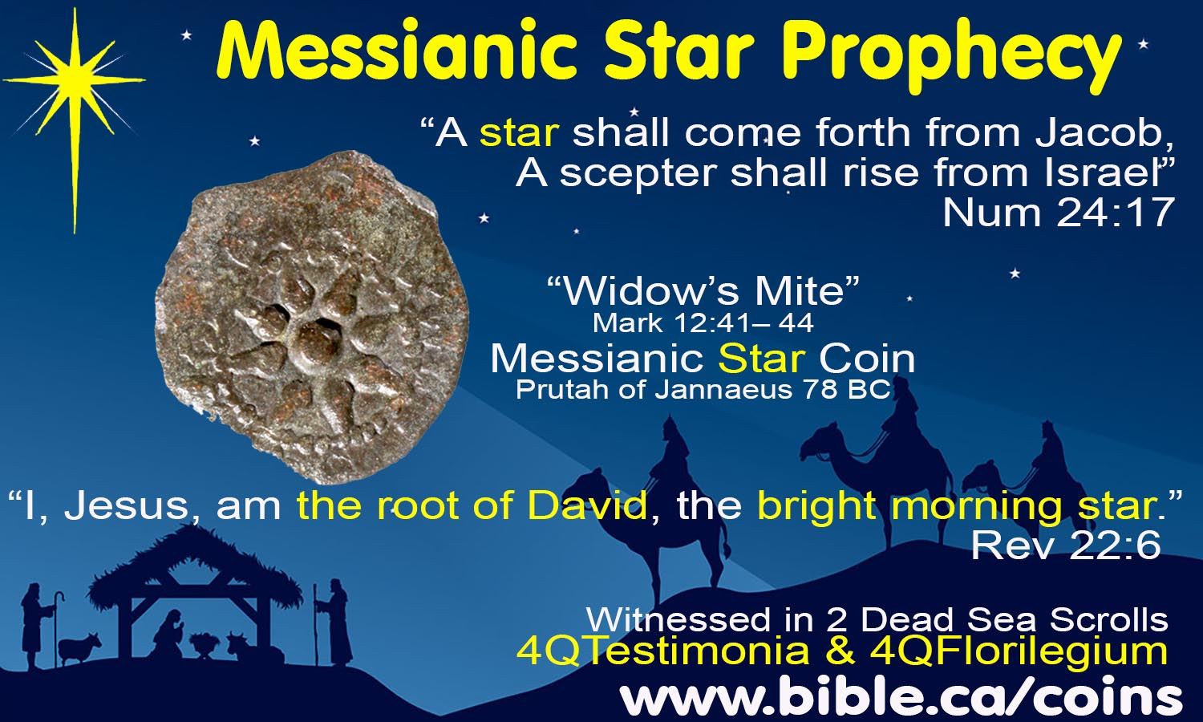

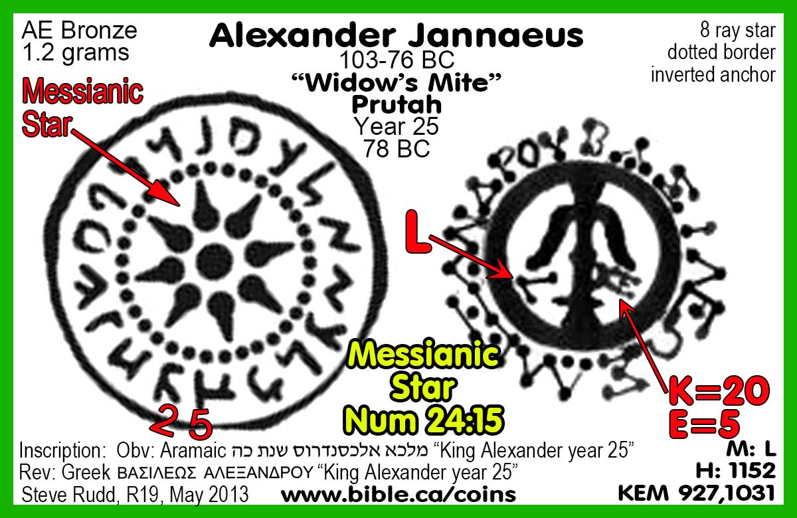

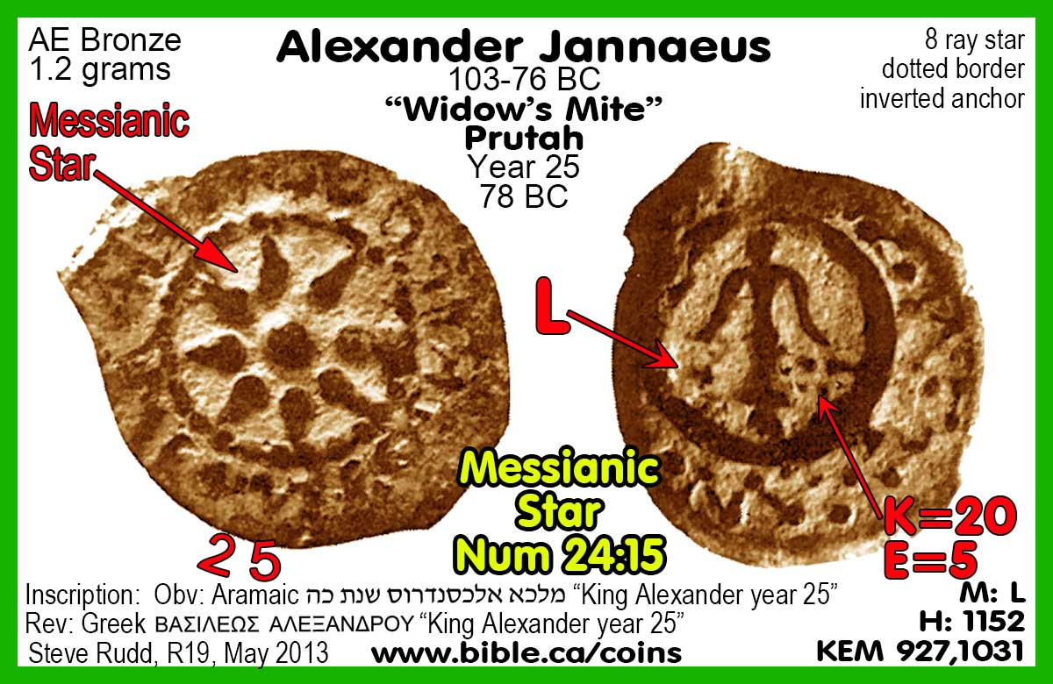
Category 2: Texts that were prophetic of a specific event that was fulfilled shortly thereafter but later understood to be a dual prophecy fulfilled in Jesus.
- 2 Samel 7:12-16 predicted that the son of David would build the temple, which was first fulfilled by Solomon, then later by Christ. (Acts 2:30–31).
- Isaiah 7:10-16 predicted two “dreaded” kings will die, (Rezin, Pekah) before Isaiah’s own son named Emmanuel is weaned (Isa 8:1-4). Herod was dreaded because he slaughtered the children and he died before Jesus was weaned in Egypt, being born of the virgin Mary. (Matthew 1:18–25)

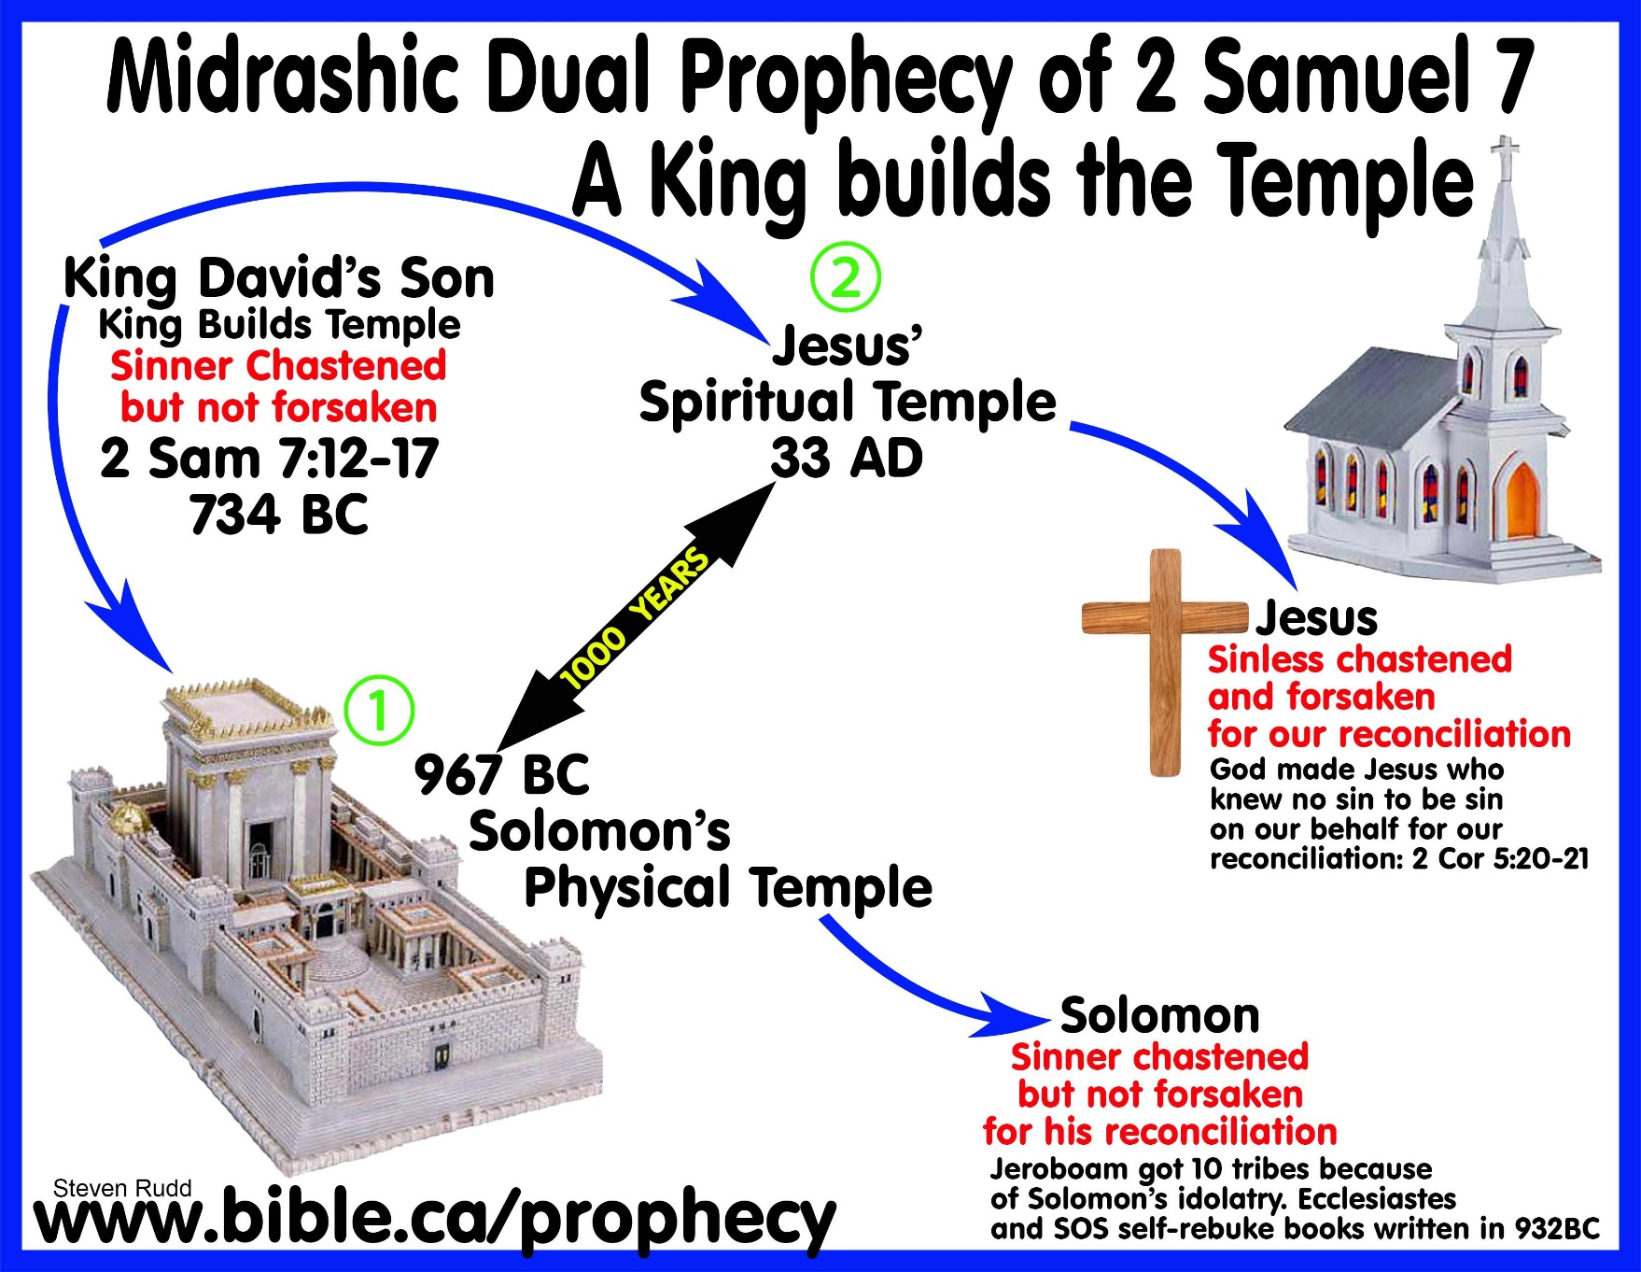

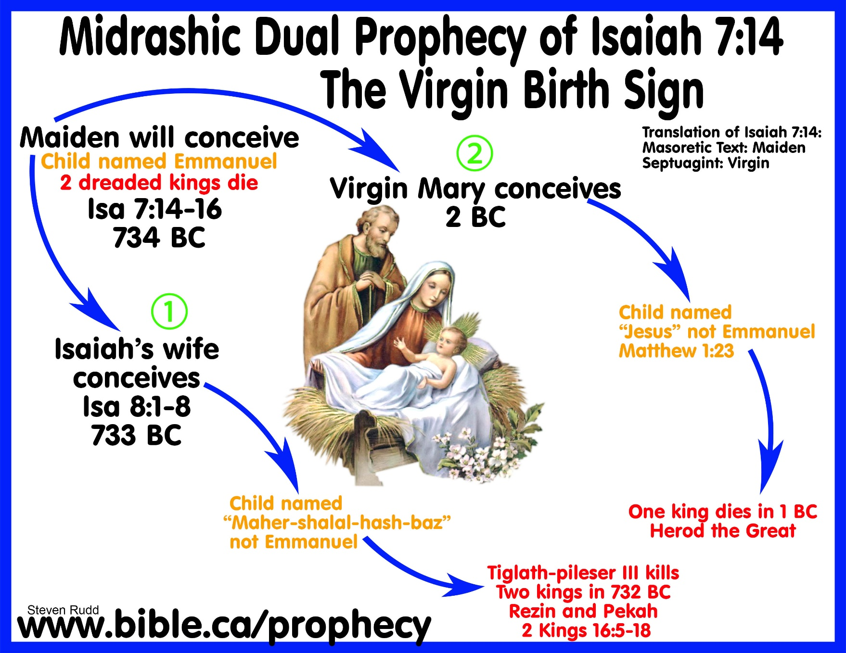

Category 3: Texts that nobody understood to be messianic prophecies until after they were identified in the New Testament as prophecies of Jesus. Taken by themselves, there is no indication they were prophetic in any way. These texts prove God’s foreknowledge, who caused two historical events centuries apart to mirror and echo one another. The first event is based upon well-established history making the typology fulfilled in Christ obvious.
- Matthew 2:15 identified God calling Israel out of Egypt in 1446 BC during the Exodus as a messianic prophecy that was fulfilled when Joseph brought Jesus out of Egypt in 1 BC after Herod died.
- John 3:14, Jesus identified the snake Moses put on the pole as a prophecy of his crucifixion. Both the Devil and Jesus were a anti-types of a snake.
- Matthew 12:38-42 Jesus identified the story of Jonah as a prophecy of his death, burial and resurrection.
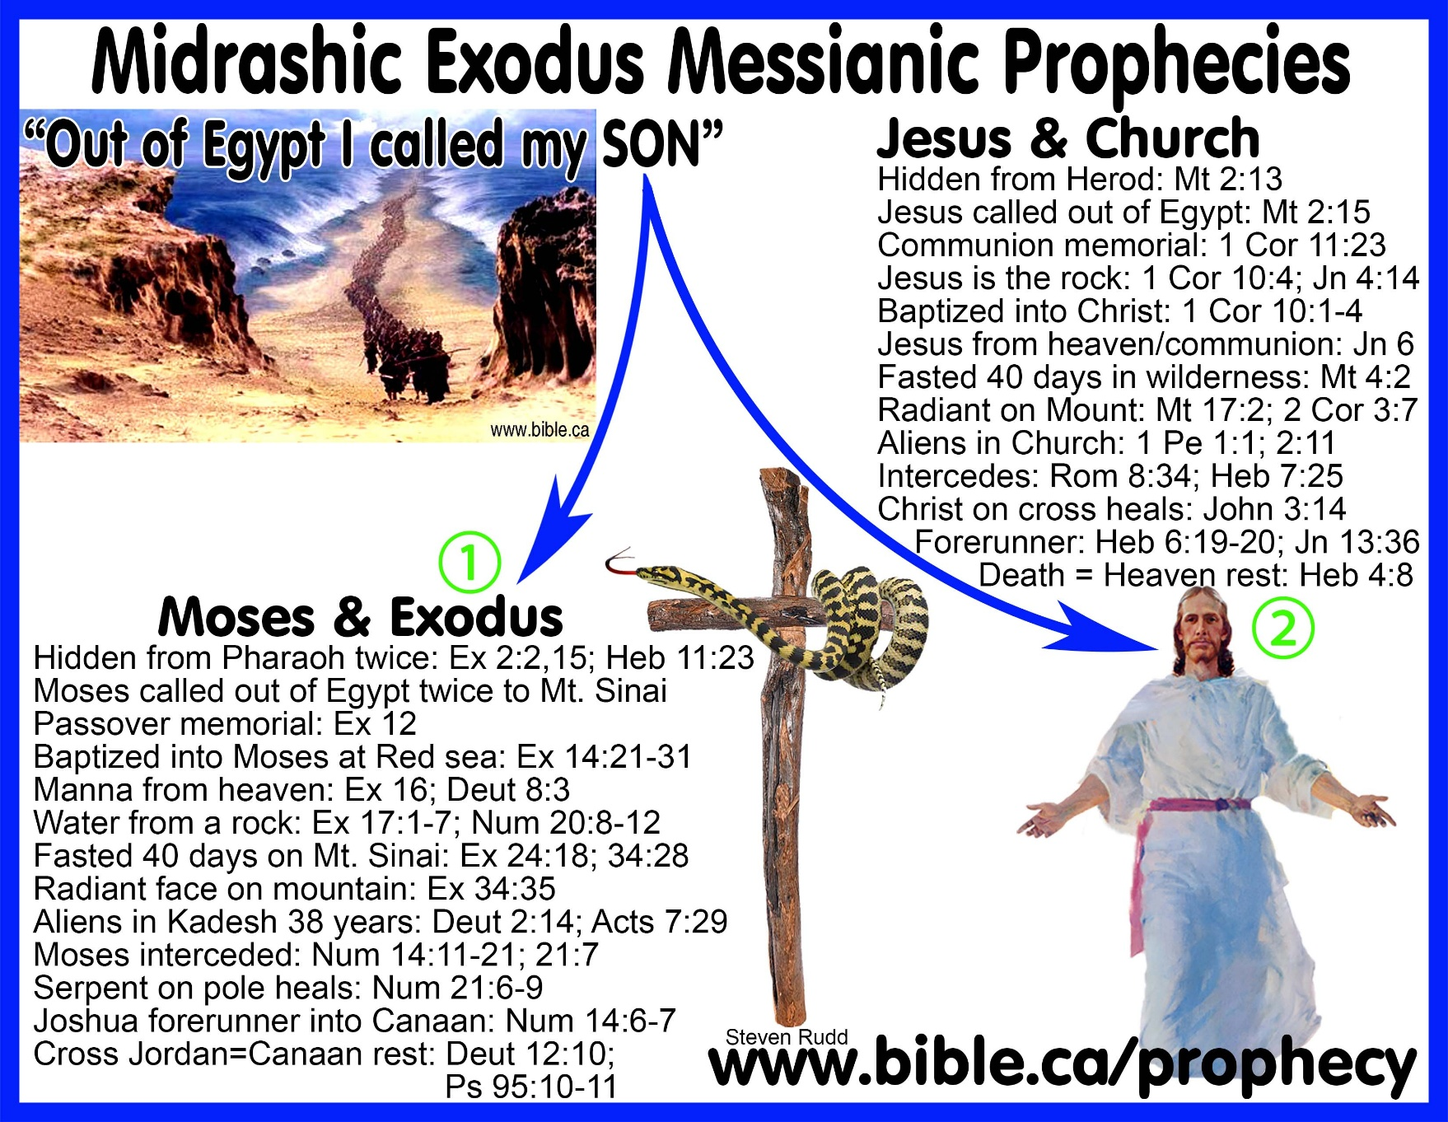

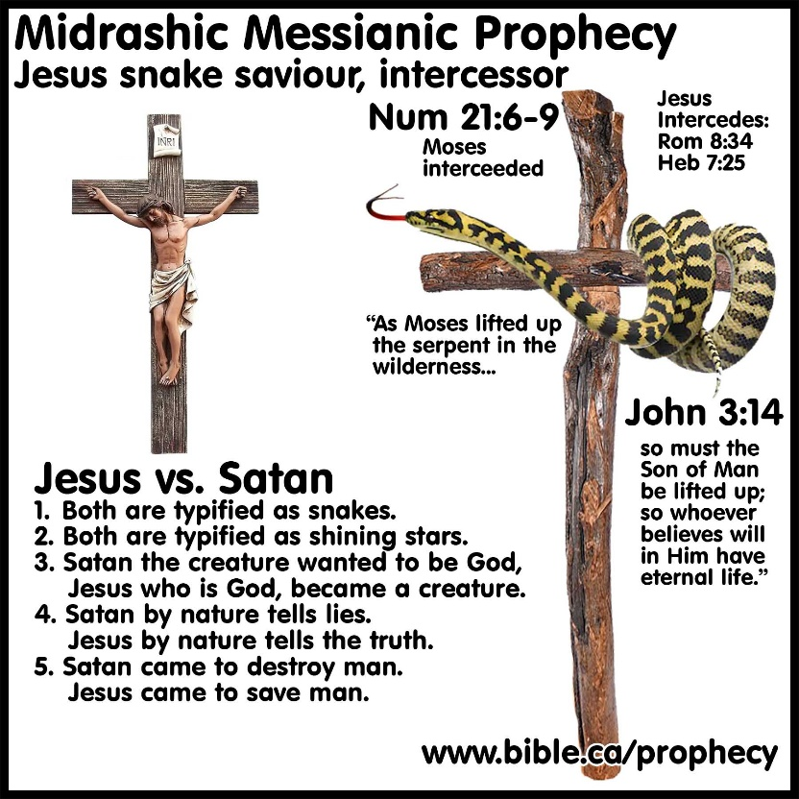
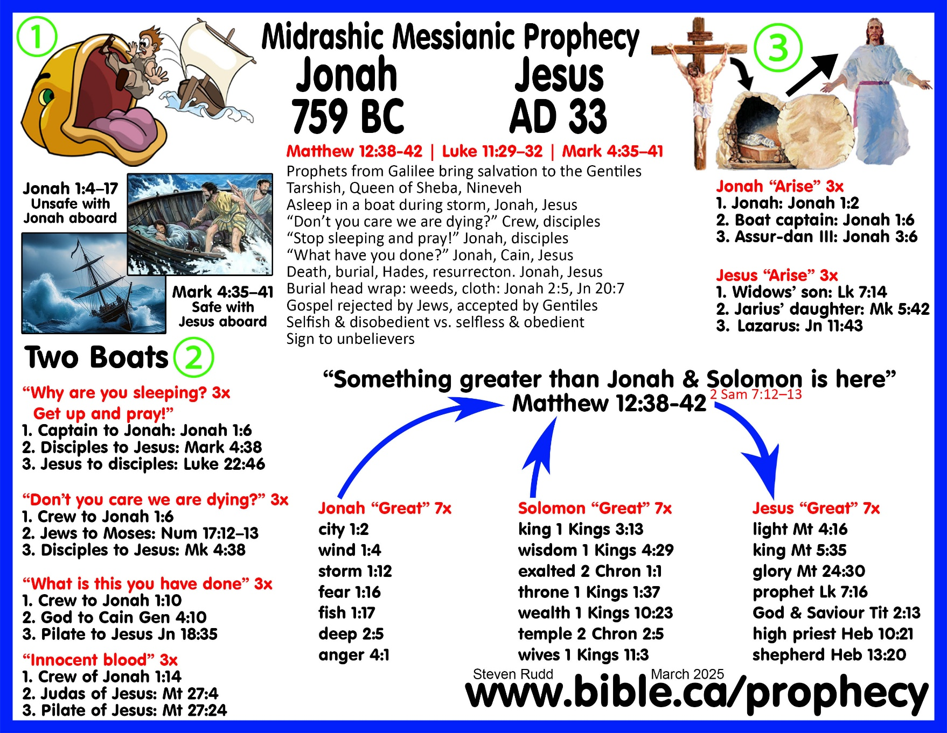

DISCUSSION: Biblical/Jewish/Rabbinical Midrashic Hermeneutic Interpretation method is what Christian’s call “Necessary Inference” and is specifically referenced three times in scripture: Ezra 7:10; 2 Chron 13:22; 24:27.
  - Bible authority is established by obeying the silence of God, command, example, and necessary inference also called Midrashic hermeneutic. What Christians today call “Necessary Inference” is identical what first century Jews called “Midrashic interpretation”. A hermeneutic is a generic term for one of many ways of interpreting the Bible. The Midrash Hermeneutic is one specific method of interpreting the Bible and was the one used by used by Jesus, the Holy Spirit, Old Testament prophets and inspired New Testament writers.
  - The clearest examples of Midrashic Hermeneutic method are the Gospel of Matthew, Paul’s writings and especially the book of Hebrews (written by Paul).
  - The Olivet Discourse becomes a triple prophecy using the Midrashic Hermeneutical method of first, the Christ coming in his kingdom on Pentecost AD 33, second, the coming of Christ in destruction in AD 70 and third, the “second coming” in Judgement at the end of time. Many elements of the Jesus’ prophecy in Matthew 24 are dual prophecies of both the coming of the Lord in Judgment in AD 70 and the future second coming. Our modern thinking wants to identify each verse in Matthew 24 as speaking either of the destruction of Jerusalem in AD 70 or the future second coming but this is impossible with most Midrashic prophetic messianic texts. The final product is a nice neat list of two sets of verses, each applying to two separate events. The error of this approach is becomes evident when you try to do the same thing in the dual prophecies of Isaiah 7:14; Isaiah 53 and 2 Samuel 7:14. The correct approach is to view all of Matthew 24 as a dual or triple prophecy.
  - The book of Ezekiel was dual prophecy of the destruction of Jerusalem in 587 BC and AD 70. Revelation itself is an exact chapter by chapter, thought by thought remake of the book of Ezekiel. The Midrashic Hermeneutic allows us to use Ezekiel to decodes Revelation.
  - Modern Jewish Rabbis use the Midrashic hermeneutic in their synagogues and are intimately familiar with it. When Jewish Rabbis today are critical with the way Matthew connected messianic prophecy in the Tanakh to Jesus of Nazareth, they are being hypocritical because their own methods seen in their own rabbinical writings are many times more spatial, abstract and speculative.
  - Midrash is how Christians today determine faith and doctrine in the church which includes obeying the silence of scripture, direct command, approved apostolic example and inference as witnessed in how the Christians in Acts 15 refuted the need for the gentiles to be circumcised to be saved.

